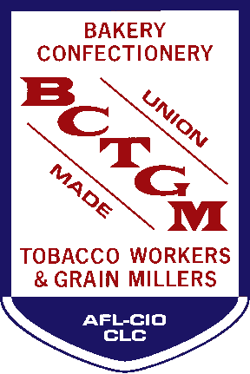
CONTACT
Corrina Christensen For Immediate Release
Cell: 240-475-8765 October 14, 2022
email: cchristensen@bctgm.org

MEDIA ADVISORY: BCTGM Members to Demonstrate Outside Hormel HQ in Austin, Minn.
After nearly two months on strike, BCTGM members at Hormel’s Corn Nuts plant in Fresno, California are traveling to the Company’s Global headquarters to demand an in-person meeting with the CEO.
WHO: BCTGM Local 85 members from California, Minnesota BCTGM members, labor allies
WHAT: Demonstrate outside Hormel HQ and call on CEO Jim Snee to meet
WHERE: One Hormel Place, Austin, MN 55912
WHEN: Wednesday, October 19, 2022 at 1:00 p.m.
After two months of rising tensions and no agreement, striking union members from the Hormel Foods owned Corn Nuts production facility in Fresno, Calif. will travel to the Company’s Global Headquarters in Austin, Minnesota on Wednesday, October 19 to demand a meeting with CEO Jim Snee.
The workers are members of the Bakery, Confectionery, Tobacco Workers and Grain Millers International Union (BCTGM) Local 85 and have been on strike since August 15. The company has imposed drastic changes to the workers’ health insurance plan without consulting with the workers or negotiating with the Union as the Company is contractually obligated to do. These changes have caused massive increases in costs and hardships for BCTGM members and their families.
On October 11, the Union sent a certified letter to CEO Snee requesting a meeting on October 19, “for the purpose of resolving this dispute and achieving a fair contract.” No response has been received to date, so Local 85 representatives and striking union workers are taking the fight to the Company’s front door.
Two of the striking union members traveling to Austin have faced significant medical and financial distress due to the Company’s dismantling of the workers’ health insurance:
John Schneider has worked at the Corn Nuts plant for 15 years. He is a two-time cancer survivor who is thankful for the decent health care package he received during his treatments when the facility was owned by Kraft-Heinz. Under the new ownership of Hormel Foods Inc., his former health care package was eliminated and replaced with an unaffordable and substandard medical plan. John now faces outrageous out-of-pocket health care costs that no working person could afford. He is very concerned that he will not be able to afford his cancer screening and imaging, which are medically necessary to monitor his health condition.
Abel Avila has worked at the Corn Nuts facility for 22 years. Abel’s wife recently sustained a serious injury at home that required medical attention and a subsequent surgical procedure. Abel now faces a shocking $9,000 bill. Abel pays significantly more out of his paycheck every week for a medical plan he simply can’t afford to use.
###

